# WPA3 Timing CTF Guide – Level 1

## Introduction

Welcome to the WPA3 Timing CTF! In this CTF we will see how we will use a side-channel to find out a Wi-Fi password using an offline dictionary attack. We will attack access points that use the dragonfly handshake and see how by measuring the time it takes for the AP (Access Point) to respond to a request we can get the password.

The handshake looks like this: both parties send a commit frame, then calculate a shared key for communication and send a confirmation message.

During the derivation of the key, the client uses a hash_to_group function that looks something like this in python-like pseudo code:

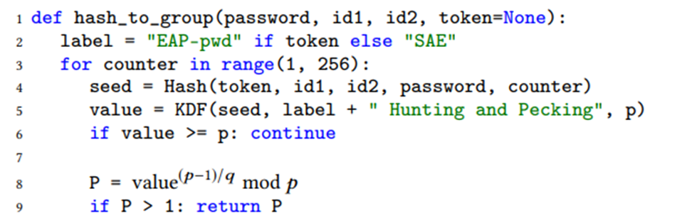

The AP hashes the password, both MAC addresses and an increasing counter to produce a random group element, and then checks if the result is indeed a group element in line 6.  
Notice that if the value is bigger than p we will do another iteration, and so on until a value smaller than p is produced (while increasing the counter every time). The number of iterations executed is therefore dependent on the password.

This attack uses the timing of the response from the AP to figure out the number of iterations executed, and by spoofing as different addresses for the client we can get a unique fingerprint of the password!

Using the fingerprint, we can get the actual password using offline brute-force.

To complete the attack, you will need to complete the missing functions!

You can find the full documentation below.

## datareader.py

Inside the file “datareader.py” you will find functions that can be used to get a fingerprint of the password based on the measurements acquired from “dragontime”.

The goal is to estimate as accurately as we can the real number of iterations that the server performed during the hash-to-group method for each spoofed MAC address.

The next few functions are going to estimate the number of iterations performed for each address, using a statistical test we call Crosby’s Box Test.

The execution time for each address is not deterministic (due to noise and other factors) but we know it is dependent on the number of iterations performed for each address. To get a fingerprint of the passwords, we first want to find out which addresses cause the same number of iterations and find “groups” of addresses that share the iteration count. Then, we can sort these groups from shortest to longest time.

To do so we need a way to tell if two addresses share the same iteration count.

This test uses the fact that some quantile ranges have less noise so are better for our analysis.

Our goal here is for each pair of samples (of two different spoofed addresses) to be able to tell if they were sampled from the same distribution, and therefore hash-to-curve has done the same number of iterations for them.

We get as parameters two quantiles $i, j$

For each sample, we define an interval between the two quantiles.

For example, if for STA “0C” the $i$-th quantile is 5000 and the $j$-th quantile is 6000 then our interval is [5000,6000]

Given two samples we want to find out if they are taken from the same distribution. So, we simply check if their intervals intersect.

The next functions will use this test to estimate the number of iterations performed.

#### 1. min_iterations(df, addrs=20, low, high)

Arguments:

* df: a DataFrame of Dragontime measurements
* addrs: number of spoofed addresses
* low: the lower quantile for the Box Test (a number between 0 and 1)
* high: the higher quantile for the Box Test (a number between 0 and 1)

Returns:

* a pandas dataframe of each spoofed address with the low and high quantiles found and the grouping based on Crosby's Box test

This function groups the addresses to groups of addresses which we estimate come from the same distribution, based on the Box Test described above. We sort those groups and assign each one an index, which is also a lower bound on the number of iterations performed during the handshake with the host.

To the dataframe we created in get_address_quantiles we add a new column "min_iters".

The algorithm is as follows:

1. Keep a counter i that starts with 1
2. Inside a loop:
   1. Sort all addresses by their 'Low Quantile' values. Pick the smallest one that has not yet been assigned to a group.
   2. Find all of the addresses that have intervals overlapping with the interval if the address from (a) (of the ones we didn't mark yet)
   3. Mark those addresses as group “i” in the "min_iters" column
   4. Increase i
3. Until all addresses have a group assigned. Notice that the group number is a lower bound.

What we did here is grouping the addresses using Crosby’s box test and sorting the groups.

The final stage will be to use the groupings we made and the lower bounds to get a more accurate estimation of the actual number of iterations performed for each group.

We can assume with good probability that the number of iterations performed for the groups with “min_iters” <= 3 is equal to their “min_iters” value. Using this assumption, we can estimate the time it takes to perform a single iteration, and then get a more accurate estimation for the remaining groups.

#### 6. iterations(df, addrs=20, low, high)

Arguments:

* df: a DataFrame of Dragontime measurements
* addrs: number of spoofed addresses
* low: the lower quantile for the Box Test (a number between 0 and 1)
* high: the higher quantile for the Box Test (a number between 0 and 1)

Returns:

* a list of estimated iteration counts for each address

This function combines everything we did so far.

1. First calculate the average time a 1-iteration execution takes. For this you can average both quantiles for each address, and average across all addresses within the first group
2. For i <= 4 until all addresses were estimated: calculate the average time of the group with min_iters == i in a similar manner to the way you calculated the average time of a 1-iteration execution.
3. Estimate the true number of iterations like so:  
   1 + (((avg of group i) - (avg of group 1)) / (time of 1 iteration))
4. Finally return the estimated values as a list.

## find_matches.py

In this file you will need to implement a program that transforms the csv file returned by fingerprint.c into a KDTree, and then find the closest matches of new fingerprints to it.

#### 1. create_tree(fp)

Arguments:

* fp: csv filename

Returns:

* passwords: a list of the passwords
* tree: k-d Tree of all the fingerprints, listed in the same order as the passwords

This function creates a KDTree and returns it, together with the passwords.

#### 2. __main__(argv)

Arguments:

* argv[1]: timing measurements filename
* argv[2]: fingerprint csv filename
* argv[3]: optional variable k-number of closest matches to print. default 5.

Prints out the k closest matches to the measurements data in the csv file.

## Running the attack

After completing the missing code in all the files, run:

$ sh setup_user.sh $(<MAC_AP) wlan0

You can replace “wlan0” with your Wi-Fi device, find it with ip addr or ifconfig.

Use dragon time to gather measurements of the time AP takes to respond to spoofed commit frames:

$ sudo ./dragontime -d $(<DEVICE) -a $(<MAC_AP) -o measurements.txt

After getting 100 measurements, stop dragontime with CTRL+C.

Use fingerprint to build a dictionary of fingerprints for all the passwords in the password list:

$ ./fingerprints passwords.txt out.csv

You will generate a CSV file “out.csv”.

In find_matches.py, use datareader.extract_data to convert the data to a DataFrame.

Use datareader.iterations to calculate a fingerprint for the password and use fitting parameters for “low” and “high”.

You can experiment with different intervals to see what works best. You can also graph the quantiles of each measurement using datareader.qplot(), and see what range looks “clean” and without much noise. note that the range shouldn’t be too big.

Finally, once you have your fingerprint, find the ones that are most similar in the dictionary:

$ python find_matches.py measurements.txt out.csv

If everything works right, the most similar should be the true password!

## Testing

In the folder “example” you will find example measurements for a password “12345678q” for your own testing purposes. Provided are also outputs for some of the functions in “datareader” for given parameters, and the file “exemple_out.csv” is the output of “fingerprint“ for the MAC addresses that you can find in 12345678q.txt.

Good luck! ☺